

Under the Guidance of
Mr. Santanu Sasmal
IBM SME and EXPERT
SESSION: 2025-26

Submitted By
Student name – SATYAM KUMAR
Reg No.11306

RUNGTA INTERNATIONAL SKILLS
UNIVERSITY
BHILAI ,
CG
File Compression Simulator

(
Using Core Java & OOP Concepts
)
RU-100-01-00012

Object Oriented Programming With Java
Project Interim Report

On
Bachelor of Technology in Computer Science &
Engineering with AI and ML in association with IBM
SCHOOL OF COMPUTER SCIENCE AND E
NGINEERING

(
April
2026)

Abstract
The Vehicle Rental Management System is a Java-based application developed using Object-Oriented Programming (OOP) concepts. This project focuses on managing rental services for different types of vehicles such as cars and bikes.
The system is designed to simplify rental operations by calculating rent dynamically based on the type of vehicle and number of days. It reduces manual effort and ensures accurate rent calculation.
The project demonstrates key OOP concepts such as inheritance, polymorphism, method overriding, constructors, and dynamic method dispatch. A base class named Vehicle is created, and subclasses like Car and Bike extend it to provide specific implementations.
This system helps in understanding how real-world problems can be solved using object-oriented design. It is simple, flexible, and can be extended in the future with additional features like database integration and GUI.

Introduction
Vehicle rental systems are commonly used in services like car rentals and bike-sharing platforms. Traditionally, managing rental records manually can be complex and error-prone.
This project provides a digital solution using Java and OOP principles. The system allows users to store vehicle details, calculate rent, and display rental information efficiently.
Features:
- Managing vehicle details (number, brand, rent per day)
- Supporting multiple vehicle types (Car and Bike)
- Calculating rent dynamically
- Demonstrating inheritance and polymorphism
- Simple console-based interface

Objectives
- Manage vehicle rental records
- Calculate rent based on vehicle type
- Reduce manual calculation errors
- Demonstrate OOP concepts (inheritance, polymorphism, overriding)
- Improve coding structure using classes and objects

Scope
This project is suitable for small-scale vehicle rental businesses. It can be further enhanced by adding database integration, graphical user interface (GUI), online booking system, and customer management.

System Requirements
Hardware:
- Computer with minimum 4GB RAM
Software:
- Java JDK
- IDE (VS Code / Eclipse)

Methodology
- Program starts from the main method
- Objects of Car and Bike are created
- Vehicle details are stored
- calculateRent() method is called
- Method executes based on object type (polymorphism)
- Rent is calculated based on number of days
- Output is displayed

Flowchart (Description)
- Start
- Create Vehicle Objects
- Input Number of Days
- Call calculateRent()
- Display Output
- End 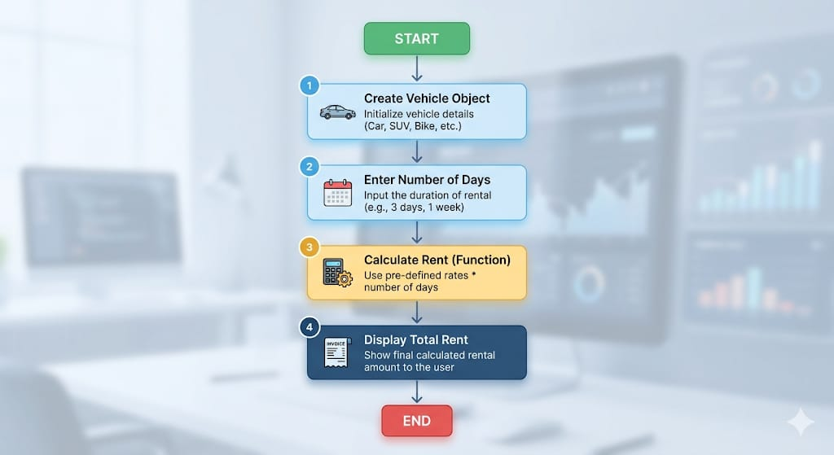

Class Diagram (Sample)
Vehicle
- vehicleNumber
- brand
- rentPerDay
- calculateRent(int days)
Car (extends Vehicle)
- Overrides calculateRent()
Bike (extends Vehicle)
- Overrides calculateRent() 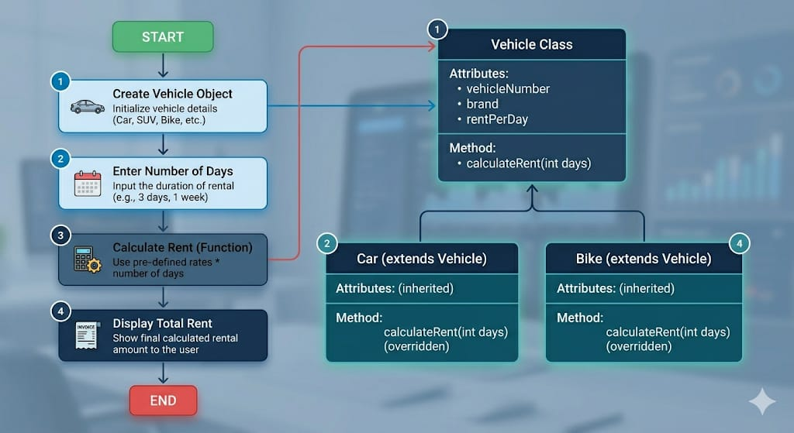

Implementation
- Vehicle Class: Base class with common attributes and method calculateRent()
- Car Class: Inherits Vehicle and applies higher rent
- Bike Class: Inherits Vehicle and applies lower rent
- Main Class: Demonstrates polymorphism using Vehicle reference

Sample Input/Output
Car Rent for 3 days: 3000
Bike Rent for 3 days: 900

Future Enhancements
- Database integration (MySQL)
- GUI using Java Swing / JavaFX
- Customer & booking system
- Payment system

Conclusion
The Vehicle Rental Management System demonstrates OOP concepts such as inheritance, polymorphism, and method overriding. It provides a simple and efficient system that can be extended for real-world applications.

References
- Java Official Documentation
- GeeksforGeeks
- W3Schools
- Java Programming Books

